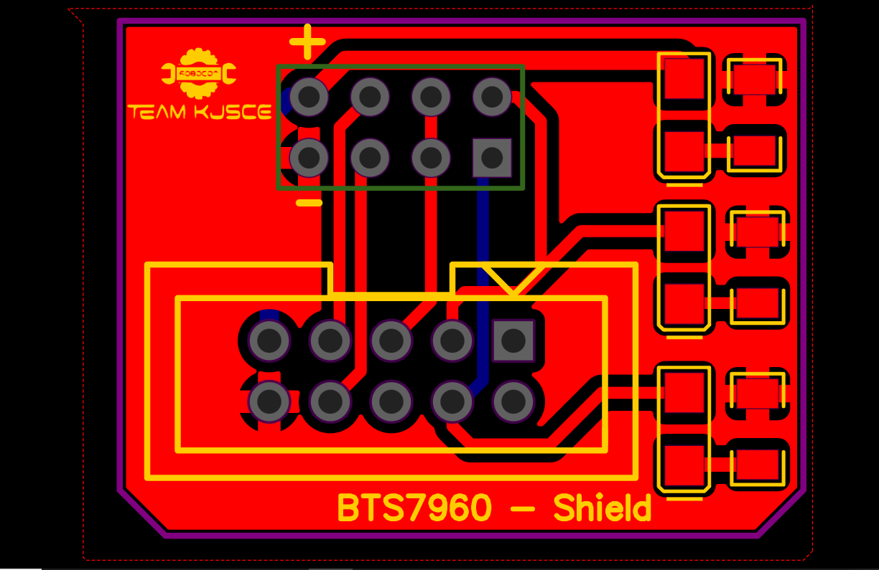



2-3 :- Direction Pin

4 :- PWM pin